

**Consumer Preferences And Buying Behaviour For Apple Products In India**

**Research by Karthik Gomadi**

**Under the guidance of**

**Prof. Shankar Gopal**

**PES UNIVERSITY, Bengaluru**

**ABSTRACT:**

Under the direction of Professor Shankar Gopal, this study examines Indian consumers' preferences and purchasing patterns with regard to Apple goods at PES University in Bengaluru. Despite early difficulties, multinational technology behemoth Apple Inc. has positioned itself effectively in the Indian market. The research looks at the variables that affect customer choices, such as cost, product attributes, reputation of the brand, and cultural influences. Data was gathered from more than 100 respondents, covering a range of demographics, using a mixed-methods approach that included qualitative and quantitative analysis. The results show that Indian consumers are very satisfied with their purchases, have favorable opinions of the Apple brand, and want to keep buying Apple goods in the future.   
  
Important conclusions show that, when it comes to making purchases, Indian consumers are heavily impacted by Apple's image as a brand, product attributes, pricing policies, and cultural preferences. According to the research, Apple goods are highly regarded by customers, who attribute this to their perceived quality, easy ecosystem integration, and successful marketing initiatives. Additionally, the survey shows that Indian customers have favorable opinions of the Apple brand, demonstrating a strong attachment and intention to purchase in the future.

According to the research, Apple's achievement in India can be linked to its capacity to modify global business plans in response to regional market conditions, successfully meeting the demands and preferences of customers. With India being a key market for digital connection and technology adoption, Apple is well-positioned for development thanks to its strategic investments in partnerships, local production, and retail expansion.

**INTRODUCTION:**

Apple Inc. is a global technology firm based in the United States that has transformed the technology industry by developing innovative applications for personal computers, tablets, smartphones, and accessories. On April 1, 1976, Steve Jobs, Steve Wozniak, and Ronald Wayne formed the company known as Apple Computers as a partnership. The Apple I, a computer that Wozniak completely developed and constructed by himself, is the company's debut product. When Steve Jobs and several Apple staff members, notably Jef Raskin, visited Xerox PARC in December 1979, they saw the Xerox Alto, which had a (GUI). After negotiating a use for PARC's technology, Apple was given the opportunity to purchase shares at a discounted price. A GUI was first included into Apple products, beginning with the Apple Lisa, as a result of Jobs' visit. Even though the Lisa was the first widely available GUI computer, its high price and constrained software alternatives contributed to its demise as a business.

Due to pent-up demand, the business changed course and released three lower-cost versions in October 1990: the Macintosh Classic, the Macs LC, and the Macintosh IIsi. All three models enjoyed considerable sales growth. The wildly popular PowerBook, which debuted in 1991 from Apple, established the current form factor for practically all laptops made today. In the previous year, Apple unveiled System 7, a significant update to the operating system used on the Macintosh that included new networking features and a colored interface.

Revenue increased as a result of the popularity of the PowerBook and less expensive Macs. Apple was doing quite well for a while, releasing new products at a growing profit margin. The years 1989–1991 were dubbed the "first golden age" of the Macintosh by the magazine MacAddict.

On February 9, 1997, the board approved the NeXT acquisition, and Jobs rejoined Apple as an advisor. Amelio resigned on July 9, 1997, following a boardroom coup orchestrated by Jobs, following three years of record-low stock prices and catastrophic financial losses.

After the board appointed Jobs as acting CEO, he looked over the board's product range. people reduced its computer products to the essentials, eliminated 3,000 people, and discontinued 70% of its models. August 1997 was the following month, when Steve Jobs persuaded Microsoft to invest $150 million in Apple along with a pledge to keep creating Mac software.

Jobs announced the rebranding of Apple Corporation to Apple Inc. during his keynote address at the Macworld Exposition on January 9, 2007, citing the company's shift in focus from pcs to electronics for consumers. The iPhone and Apple TV were both unveiled at this event.Within the first 30 hours of sales, the business sold 270,000 iPhone devices, earning praise for the gadget as "a game changer for the industry". With the June 2010 debut of the iPhone 4, Apple added multitasking, FaceTime video chatting, and a redesigned design featuring a visible stainless steel framework housing a phone's antennae system. Subsequently, Apple updated the iPod lineup once more that year with the release of the iPod Nano, an iPod Touch with FaceTime, plus an iPod Nano that reintroduced the clickwheel buttons from previous models. Additionally, it brought in the second generation Apple TV, which was smaller and less expensive and supported movie and show rentals.

Apple's smartphone lineup, powered by the iOS operating system, includes the iPhone. Steve Jobs introduced the original iPhone on January 9, 2007. Every year after that time, fresh models were introduced. Apple's tablet lineup, which includes the iPad, runs iPadOS. The announcement of the first iPad took place on January 27, 2010. The iPad is primarily promoted for use in video conferences, gaming, art creation, document editing, and multimedia consumption. Apple also produces a number of items that fall under the "Wearables, Home and Accessories" category.

"Byte into an Apple" was the initial tagline of Apple, which was created in the latter part of the 1970s. The phrase "Think different" was utilized in marketing materials from 1997 to 2002, and it is still strongly linked to Apple. Additionally, Apple uses slogans for certain product lines. For instance, "iThink, therefore iMac" was used to market the iMac in 1998 and "Say hello to iPhone" has used in ads for the iPhone. "Hello" also served as the launchpad for the Newton, iMac ("hello (again)"), iPod, and first Macintosh.

Over time, Apple has increased both its amount of physical stores and its geographical reach; as of December 2017, the company had 499 shops in 22 different countries. With sales of over $16 billion worldwide in 2011, Apple is now regarded as one of the best retail establishments because to its robust product line. Starting in May 2016, Apple Stores saw a major renovation.

France penalized Apple €1.1 billion on March 16, 2020, for their collusion with two distributors to cripple independent dealers in order to limit competition and maintain high pricing. About half of the French retail industry now has pricing for Apple items, such PCs and iPads, that are aligned thanks to the partnership. The violations took place between 2005 and 2017, but were only brought to the attention of French regulators in 2012. This was due to a complaint made by eBizcuss, an independent reseller.The creator of the well-known game Fortnite, Epic Games, filed lawsuits against Google and Apple on the 13th of August in 2020, following the removal of the game from both platforms' app stores. The litigation started when the game was stopped by Apple and Google due to the introduction of a direct payment method that avoided the fees that the companies had set.

Data of the apple company over the years with different factors:

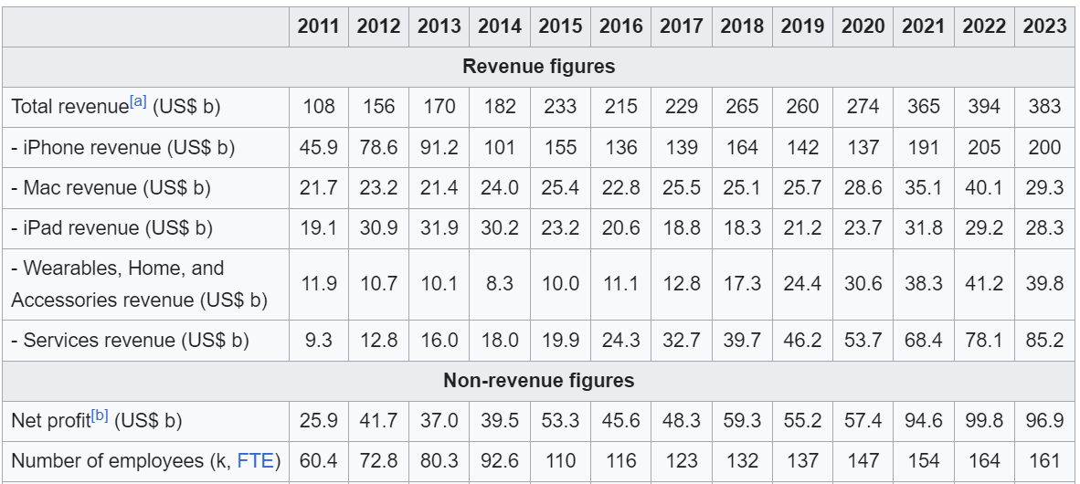

As continuing the findings we can see the figures above, which can be said as massive growth over the years through its research and developments. As of 2023 total revenue is 383US$ b, were iphones contributed 200US$ b, we can see the impact of mobile phone has played important role in the Industry.

There are many other factors other than Research & Development,

Such as affordability , financial facility, alternative options , competitive pricing etc…

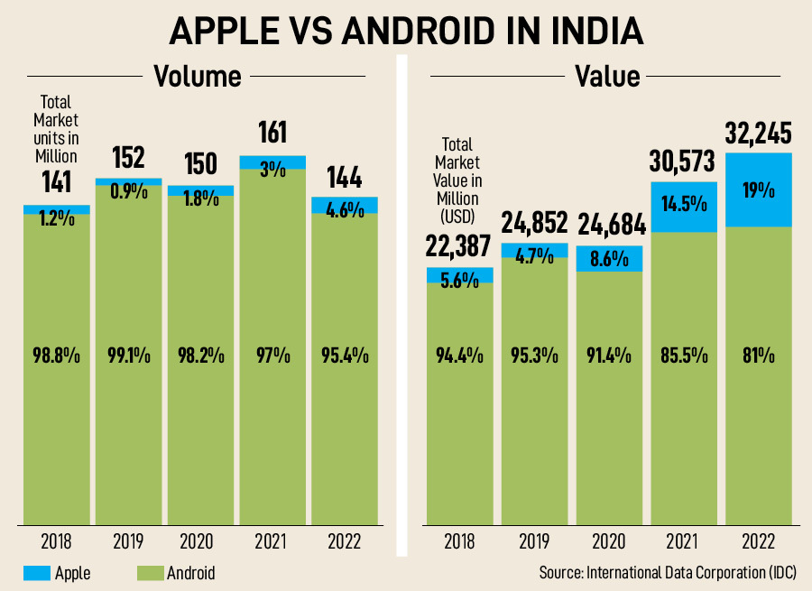

Earlier there was a time were apple was called as the rarest and was having the slow sales due to its pricing. During that time android was ruling the industry, as it was having multiple players in the market were apple was the only company to use IOS interface.

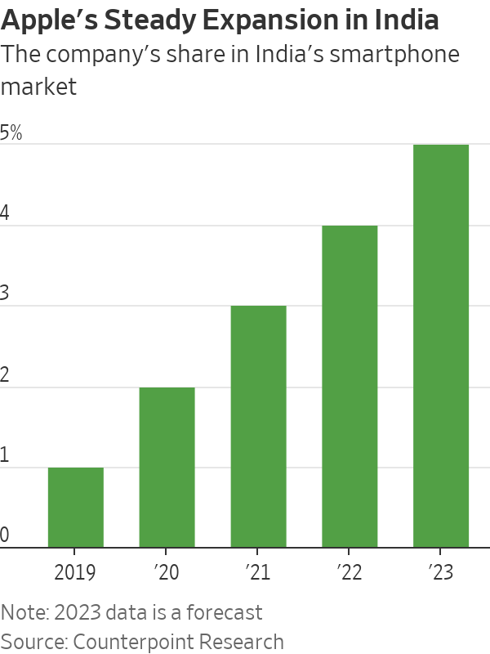

**LITERATURE REVIEW:**

Title: Explaining Consumer Behaviour in Developing Markets:

Review: Studies show that due to variations in economic situations, cultural impacts, and market dynamics, consumer behavior in developing markets such as India differs from that of established nations. These elements influence customers' impressions of brands and their own buying habits.

Title: Customer Loyalty in the Mobile Industry:

Review: Consumer decisions about smartphone purchases are heavily influenced by brand loyalty. Even in highly competitive areas, Apple's success may be attributed to its tremendous brand equity and devoted client base.

Title: Cultural Aspects Influencing Consumer Behavior

Review: Cultural aspects have a big impact on how people behave. Indian consumers' tastes and purchase decisions are influenced by cultural values, customs, and social standards; thus, international businesses such as Apple must modify their strategy accordingly.

Title: The Significance of perceived worth in Consumer Choice

Review: One of the key variables influencing customer purchasing behavior is perceived value, which takes into account elements including product quality, pricing, and brand reputation. Apple's success in the market may be attributed to its ability to communicate its substantial worth through its luxurious branding and creative goods.

Title: Consumer Buying Behavior and Socio-Economic Factors Review: The buying habits of customers is greatly influenced by socioeconomic position, which includes factors like income, education, and employment. While those with lower incomes can value cost over brand, those with greater incomes are more inclined to buy luxury brands like Apple.

Title: Technology Product Adoption in Developing Markets

Review: Technological literacy, information accessibility, and perceived utility are some of the elements that affect how quickly technology products are adopted in emerging economies. The degree of technology adoption among Indian consumers varies, which affects how they behave when making high-tech purchases like those made by Apple.

Title: The Effect of Advertising on customer Behavior

Review: By influencing perceptions and influencing buy intentions, effective advertising may have a major impact on customer behavior. Apple's marketing strategies in India, which emphasize the devices' aspirational value, have proven crucial in drawing customers.

Title: Consumer Perceptions Regarding International Brands

Review: Quality perception, reputation, and the origin country impacts are some of the elements that influence consumer sentiments toward international brands. International brands, such as Apple, are more appealing to Indian customers since they are frequently seen as desired and superior.

Title: Digital Effect on Customer purchase Decisions

Review: Consumer purchase decisions are greatly influenced by the digital landscape, which includes social media, e-commerce platforms, and online reviews. Indian buyers of Apple products are becoming more and more informed by using internet sources.

Title: Customer Behaviour in High-Involvement Purchases

Review: Buying an Apple product, for example, requires customers to go through a lengthy decision-making process in which they consider a variety of criteria, such as product characteristics, brand reputation, and individual preferences.

**Methodology:**

Using a combination of both qualitative and quantitative approaches, we used a mixed-methods approach to look at Indian consumers' preferences and purchasing habits for Apple products. Using stratified random sampling, a structured online survey was given to more than 100 respondents in a diversified sample to guarantee representation across various demographics, such as ages, sex, income levels, and places of residence. Demographic data, preferences, and purchase habits were all gathered for this study.

**Data Analysis:**

Survey in google forms for different demographics,

I have collected more than 100 samples for the research to see how different customers have different preferences and also I have samples of NON Apple users to see whether they have any overview towards growth of the apple in India.

Let me share the questionnaire I have used for my survey:

1. Your age
2. What is your gender
3. Occupation (employed or unemployed)
4. What is the income level of the respondent
5. **Have you purchased any Apple product in the last 12 months?**
6. What factors influenced your decision to purchase an Apple product?
7. **How would you rate your overall satisfaction with your Apple product(s)?**
8. To what extent do cultural preferences influence your choice of electronic devices, including Apple products?
9. How would you describe your overall perception of the Apple brand in India?
10. Do you see yourself purchasing more Apple products in the future?

Results can be viewed in the google sheets:

<https://docs.google.com/spreadsheets/d/1qNbkSAtB3LKoRullci9HC50_-sVfOacrohZ3Wj8pemY/edit?usp=sharing>

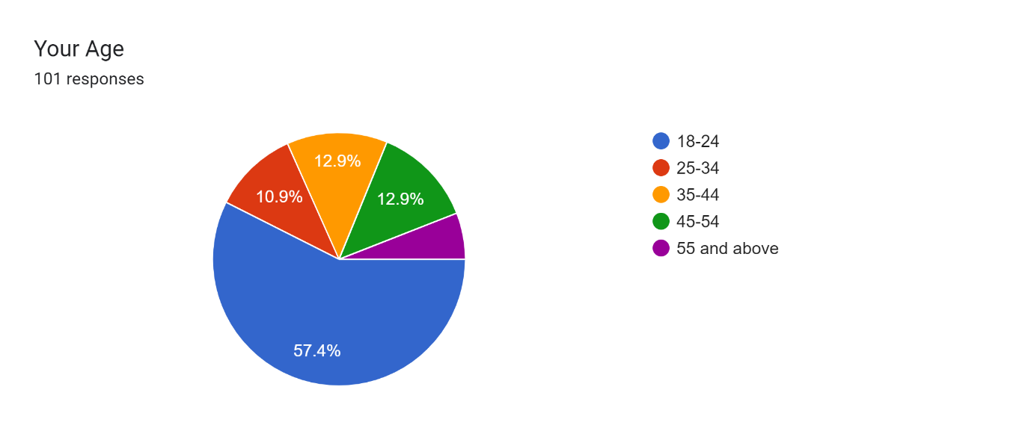

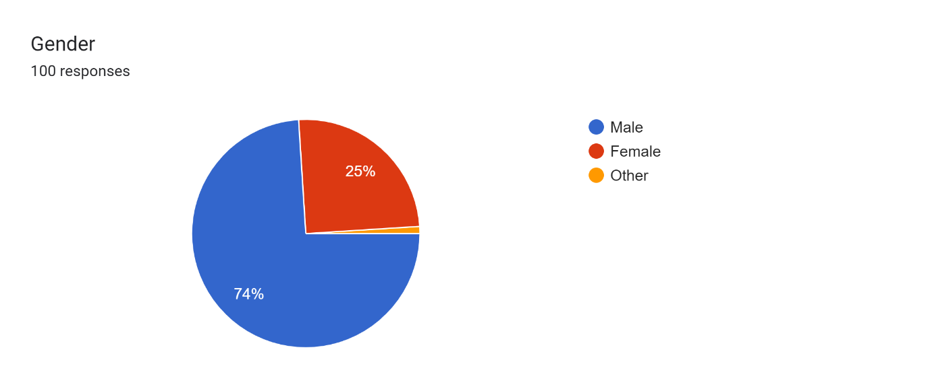

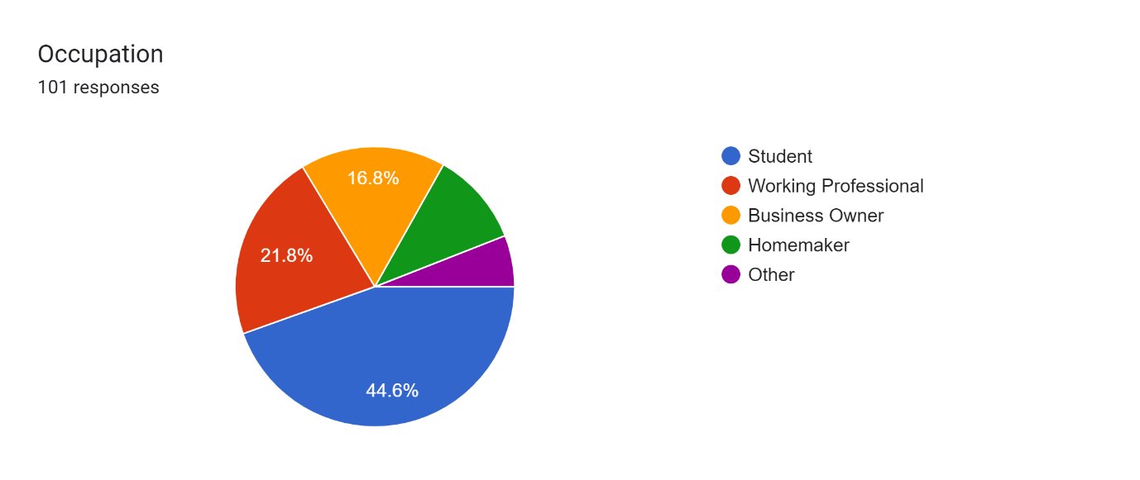

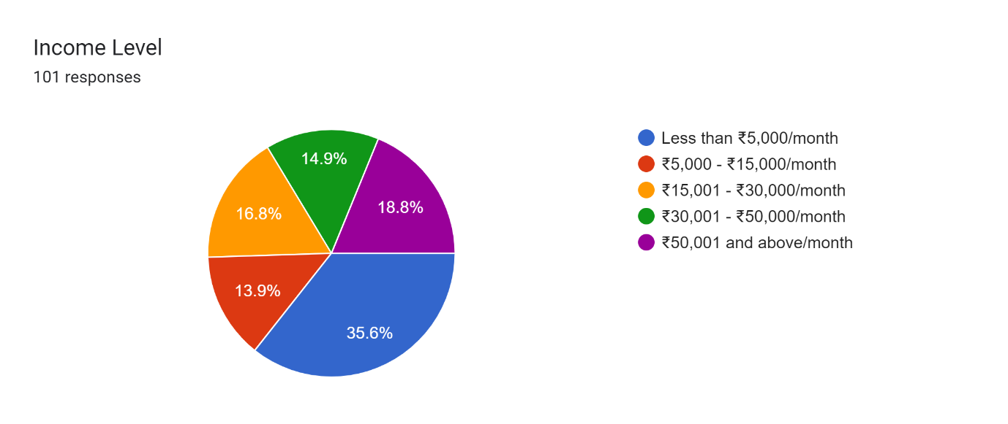

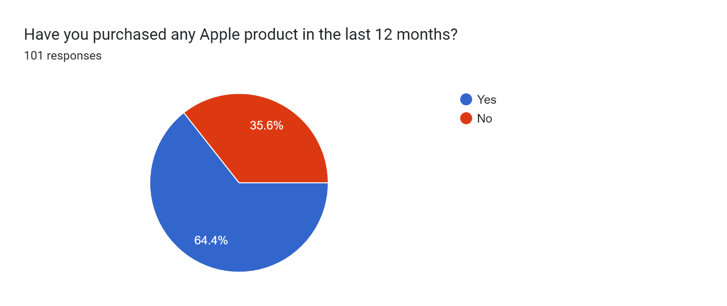

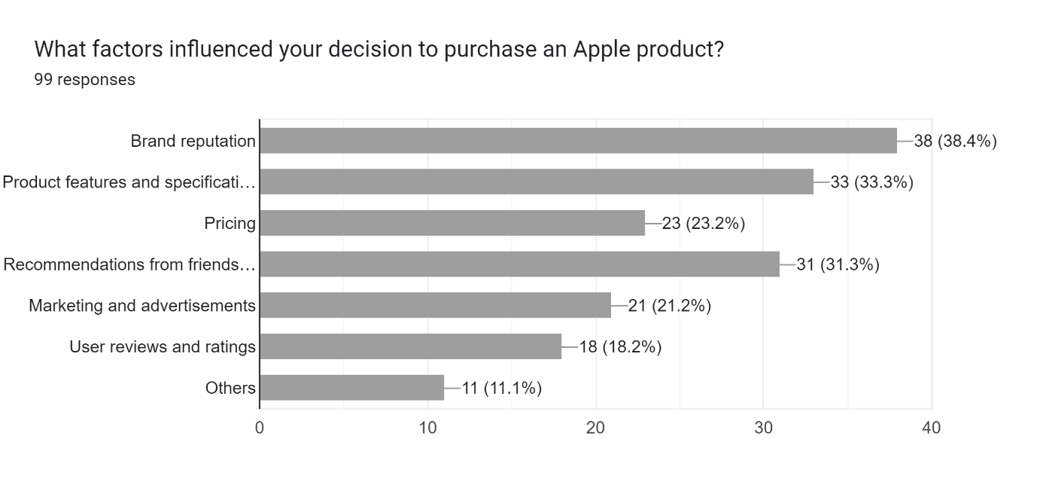

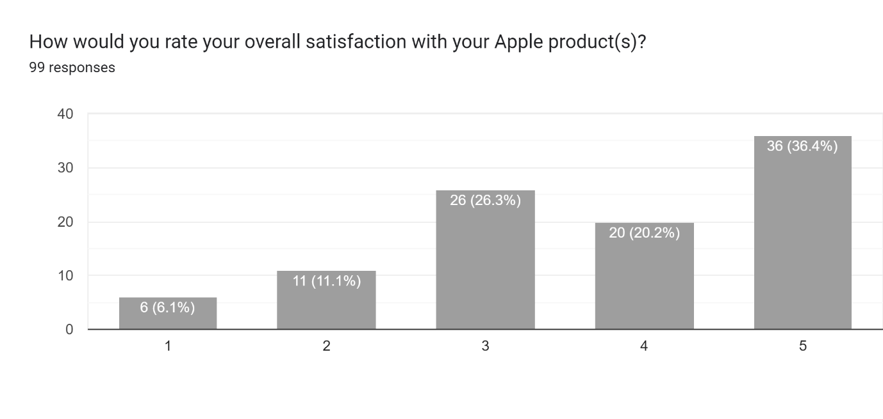

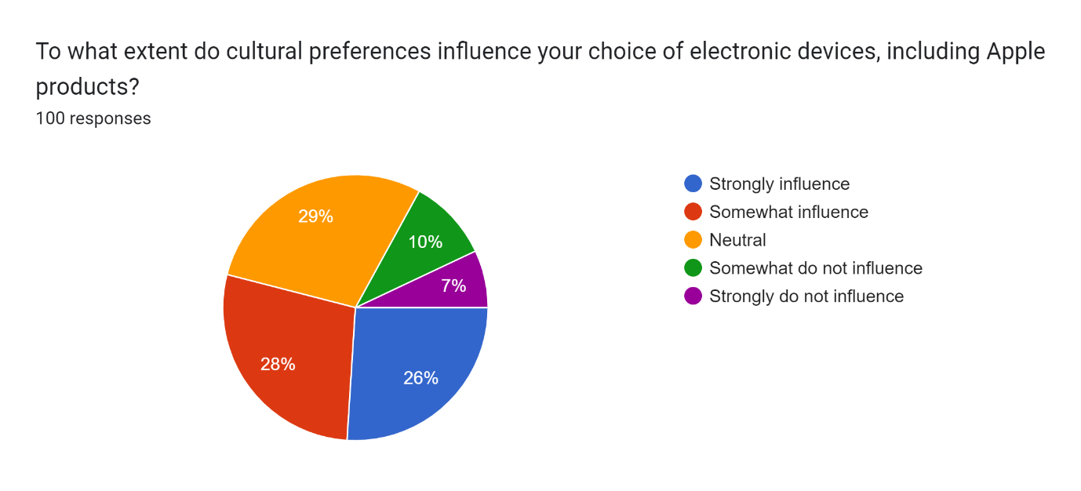

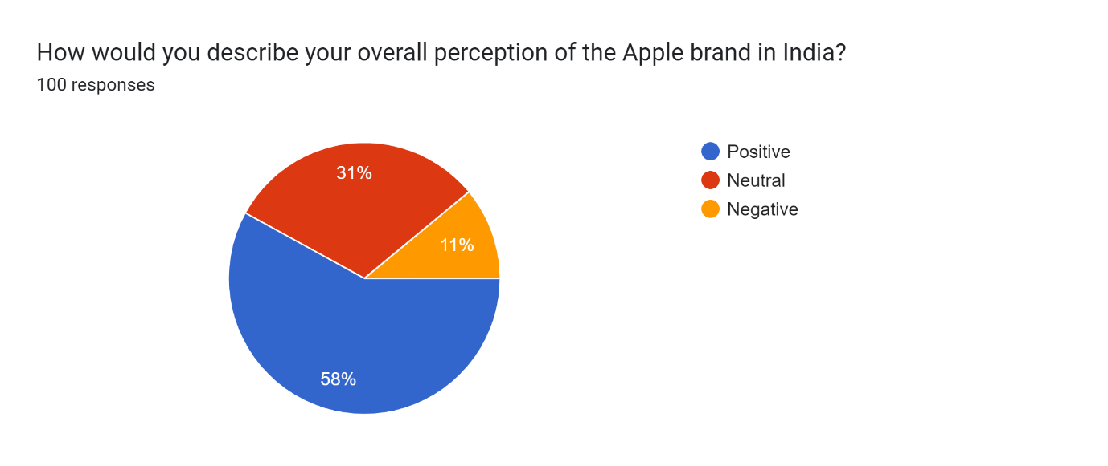

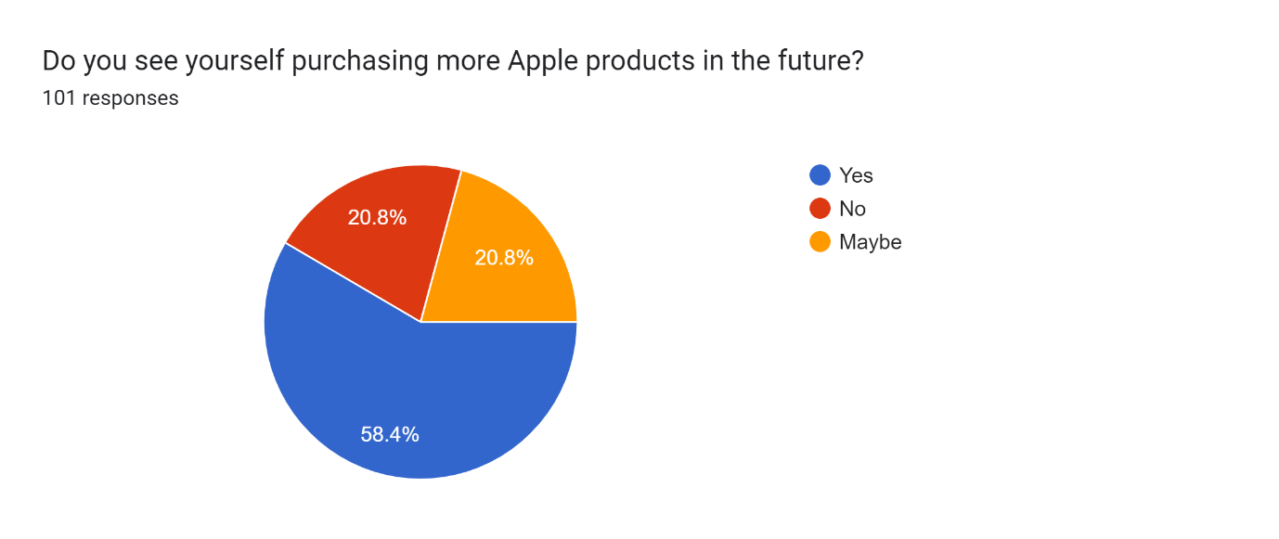

* These were the responses that I have received :
* We can see that most of the respondents were aged between 18-24, which describes that young people are very concerned about apple.
* Many of them were actually men who have good image on apple as compared to women.
* Students: Students make up the bulk of those who responded.
* Working Professionals: A sizable percentage of those surveyed are employed in the business world.
* Entrepreneurs: Among the responders are a number of entrepreneurs.
* Less than ₹5,000 per month: This income class comprises a sizable percentage of responders.  
  ₹5,000 - ₹15,000/month: This middle-low income group comprises a number of responders.  
  ₹15,001 - ₹30,000/month: A considerable proportion of participants fall into this middle-class income bracket.  
  30k to 50k per month: A large number of respondents earn between 30k and 50k.  
  ₹50,001 or more per month: A sizable portion of respondents fall into this high-income bracket.
* Less than ₹5,000 per month: This income class comprises a sizable percentage of responders.
* ₹5,000 - ₹15,000/month: This middle-low income group comprises a number of responders.
* ₹15,001 - ₹30,000/month: A considerable proportion of participants fall into this middle-class income bracket.
* 30k to 50k per month: A large number of respondents earn between 30k and 50k.
* ₹50,001 or more per month: A sizable portion of respondents fall into this high-income bracket.

**Purchase Patterns:**

You have consistently shown interest in Apple's offers as seen by your frequent purchases of their items over the past 12 months.

**Elements Affecting Purchase:**

The reputation of the brand, the features and specifications of the goods, referrals from friends and family, the price, marketing and advertising, and feedback from customers were the main factors influencing the choice to buy Apple products.

**Levels of Satisfaction:**

Ratings for general happiness with Apple goods varied, often falling between three and five stars, indicating generally good experiences.

**Cultural Impact:**

The respondents' choice of electronic gadgets, including Apple products, was somewhat impacted by their cultural preferences.

**India's perception of the Apple brand:**

With a small percentage of indifferent or negative replies, the general impression of the apple company in India was largely positive.

**Future Purchase Intention:**

Most respondents said they would probably buy more Apple items in the future, but others were unsure or inclined toward maybe.

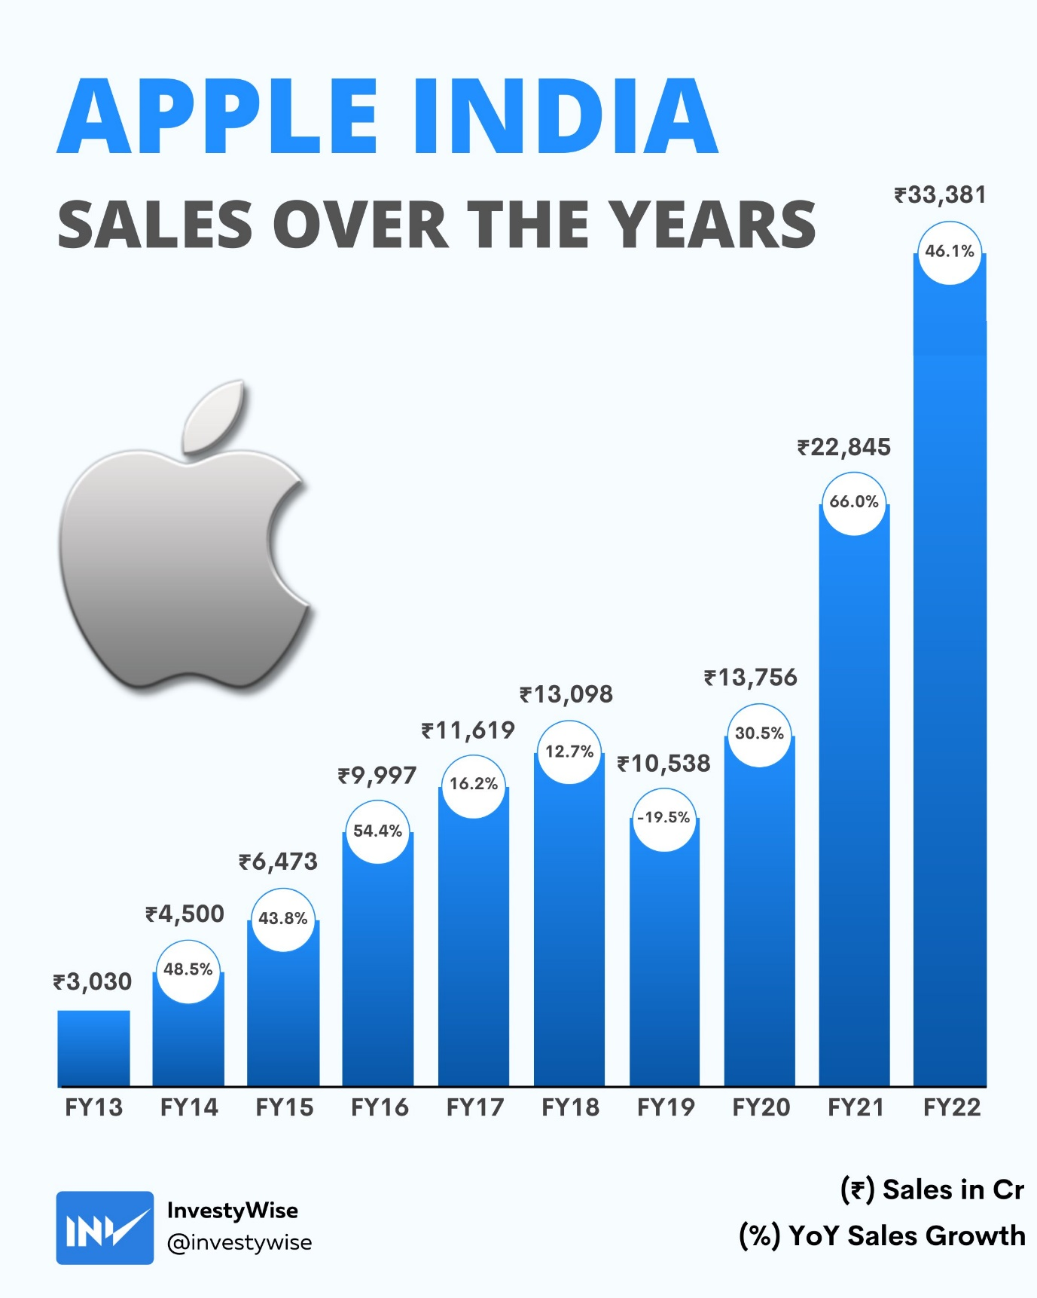

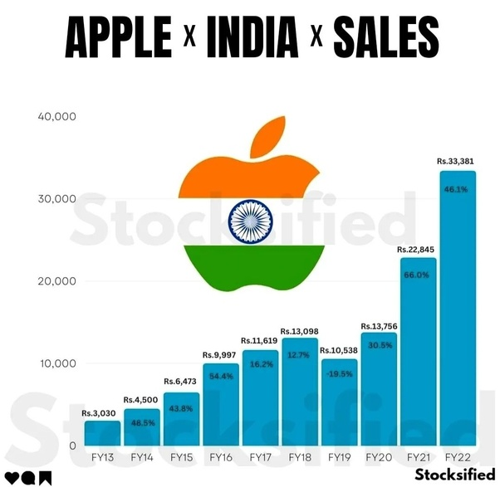

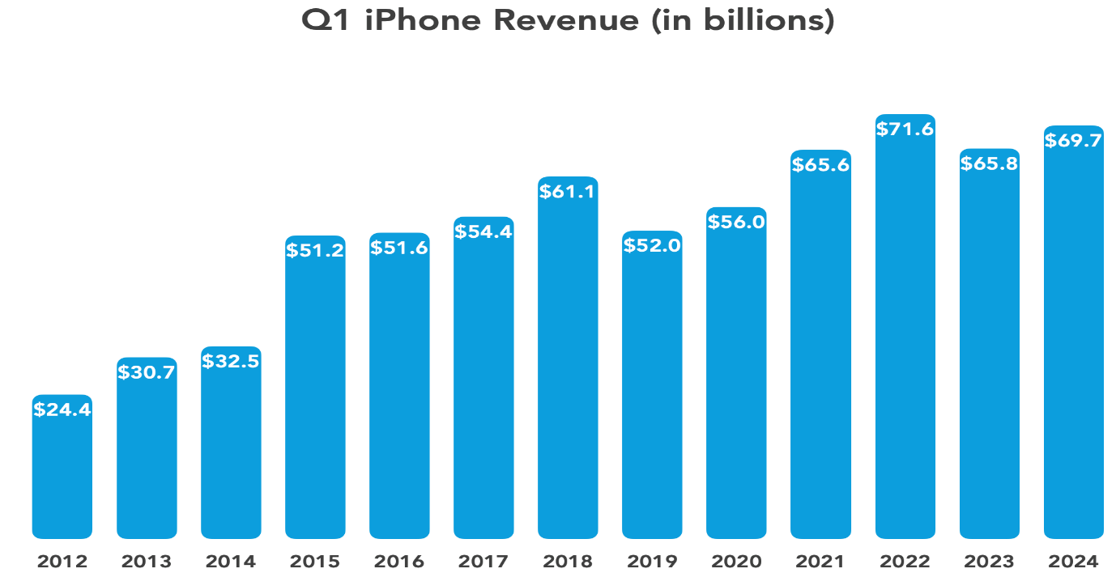

**Conclusion:**

Thanks to its innovative product offerings, intelligent market approach, and strong brand recognition, Apple Inc. has performed well in the Indian marketplace in recent years. Despite early price difficulties and rivalry from Android smartphones, Apple has been able to carve out a position for itself in India as a luxury brand that appeals to discriminating customers. Indian customers have responded well to the company's emphasis on premium products, smooth system integrating, and aspirational marketing, which has helped to sustain growth and customer loyalty. Apple has a solid outlook for purchase intent, excellent customer happiness, and positive consumer views, which puts it in a good position to keep growing its market share and presence in India's quickly changing technology sector.

Positive user evaluations, dependable customer support, and a strong store presence all contribute to the continuously high level of consumer satisfaction that Apple goods enjoy in India. Due to the company's dedication to user-focused design and ongoing innovation, its clientele has developed a strong sense of brand loyalty.

Apple's approach in India is also influenced by cultural considerations. Apple has adapted its advertising and merchandise to appeal to local tastes while upholding its worldwide reputation for quality and innovation, acknowledging the variety and interests of Indian consumers. Because of its capacity to adapt, Apple has been able to successfully negotiate the subtleties of the Indian market and forge enduring bonds with its clients.

**References:**

Sheth (2011) was J. N. Marketers should reconsider their current viewpoints and methods in light of the influence of emerging markets. 75(4) Journal of Marketing, 166–182.

A. S. Dick and K. Basu (1994). Achieving an Unified Conceptual Structure for Customer Loyalty. 22(2), 99-113 in Journal of the Institute of Marketing Science.

Gupta, S. F., and Luna, D. (2001). An Integrated Framework for Consumer Behavior Across Cultures. 18(1), 45–69, International Marketing Review.

Zeithaml (1988) V. A. A means-end approach and evidence synthesis were used to analyze customer impressions of value, price, and quality. 52(3) Journal of Marketing, 2-22.

Blackwell, R. D., Miniard, P. W., and Engel, J. F. (1995). Customer Behavior, Eighth Edition. Press Dryden.

Rogers (2003), E. M. Creativity Diffusion, Fifth Edition. Press Free.

Keller, K. L., and P. Kotler (2016). 15th edition of Marketing Management. Pearson..

Batra, R., Alden, D. L., and Steenkamp, J.-B. E. M. (2003). The Creation of Brand Value by Considered Globalness of a Brand. International Business Studies Journal, 34(1), 53–65.

Rahman, M. S., Hu, Y. J., and Brynjolfsson, E. (2013). Taking on Competition in the Omnichannel Retailing Age. 54(4), MIT Sloan Management Journal, 23–29.

M. R. Solomon (2018). Purchase, Possess, and Being in Consumer Behavior (12th ed.). Pearson.